JAVA ASSIGNMENT 22-09-2021

//Vigneshwar and Charran

package com.torryharris.mainpack;

import java.util.Scanner;

public class Main {

public static void main(String[] args) {
/*int coe=1,rows = 6;
for(int i = 0; i < rows; i++) {
for(int space = 1; space < rows - i; ++space) {
System.out.print(" ");
}

for(int j = 0; j <= i; j++) {
if (j == 0 || i == 0)
coe = 1;
else
coe = coe * (i - j + 1) / j;

System.out.printf("%4d", coe);
}
System.out.println();
}

------------------------------------------------------------------------------------------------------------------------------------------
Scanner sc = new Scanner(System.in);
System.out.println("Enter the two numbers ");
int n1 = sc.nextInt();
int n2 = sc.nextInt();
int gcd=1,lcm;
for (int i=1; i<=n1 && i<=n2; i++)
{
if( n1%i == 0 && n2%i == 0)
gcd = i;
}
lcm = (n1*n2)/n1;
System.out.println("gcd of "+n1+","+n2+" is "+gcd);
System.out.println("lcm of "+n1+","+n2+" is "+lcm);
int mark=40;

--------------------------------------------------------------------------------------------------------------------------------------
switch (mark/10){
case 10:
case 9:
System.out.println("A");
break;
case 8:
System.out.println("B");
break;
case 7:
System.out.println("C");
break;
case 6:
System.out.println("D");
break;
case 5:
System.out.println("E");
break;
case 4:
System.out.println("Fail");
break;
default:
System.out.println("invalid garde");
break;
}

---------------------------------------------------------------------------------------------------------------------------------------------
int n, remainder = 1, number, sum = 0;

Scanner sc = new Scanner(System.in);
System.out.print("Enter a number you want to check: ");

n = sc.nextInt();
number = n;

while (number > 9)
{

while (number > 0)
{

remainder = number % 10;
sum = sum + remainder;

number = number / 10;
}
number = sum;
sum = 0;
}
if (number == 1)
{
System.out.println("The given number is a magic number.");
}
else
{
System.out.println("The given number is not a magic number.");
}
}
}
------------------------------------------------------------------------

Done by:Sagar Deshmukh

5)
//to find palindrome number.
package com.torryharris;

import java.util.Scanner;

public class Main {

public static void main(String[] args) {
//checking for palindrome
Scanner sc = new Scanner(System.in);
System.out.println("enter the number");
int n = sc.nextInt();
int rem,rev=0;
int temp = n;
while(n>0)
{
rem = n % 10;
rev = rev * 10 + rem;
n = n/10;
}
n = temp;
if( n == rev)
{
System.out.println(n+" is a palindrome ");
}
else
System.out.println(n+" is not a palindrome");
}
}

output:
enter the number
1001
1001 is a palindrome

enter the number
1223
1223 is not a palindrome

--------------------------------------------------------------------------------
6)
//program to check whether entered number is Krishnamurthy number or not.(ex: 145=1!+4!+5!=145)
package com.torryharris;

import java.util.Scanner;

public class Main {

public static void main(String[] args) {
Scanner sc = new Scanner(System.in);
System.out.println(" enter the number ");
int num = sc.nextInt();
int fact=1,rem,sum=0;
int temp = num;
while(num!=0)
{
rem = num%10;
for (int i=1;i<=rem;i++)
{
fact = fact*i;
}
num = num/10;
sum = sum+fact;
fact = 1;

}
num = temp;
if(num == sum)
{
System.out.println(num+" is Krishnamurthy number ");
}
else
{
System.out.println(num+" is not a Krishnamurthy number ");
}

}
}
output:
enter the number
145
145 is Krishnamurthy number

enter the number
345
345 is not a Krishnamurthy number
------------------------------------------------------------------------------
7)
//program to find sum of even digits in a given number.
package com.torryharris;

import java.util.Scanner;

public class Main {

public static void main(String[] args) {
Scanner sc = new Scanner(System.in);
System.out.println(" enter the number");
int num = sc.nextInt();
int rem,sum=0;
int temp = num;
while( num != 0)
{
rem = num%10;
if(rem%2 == 0)
{
sum = sum+rem;
}
num = num/10;
}
num = temp;
System.out.println("sum of even digits in "+num+" is "+sum);
}
}
output:
enter the number
123456
sum of even digits in 123456 is 12

Process finished with exit code 0
---------------------------------------------------------------------------------
8)
//program to check whether the entered number is disarium number or not (ex:1)89=8^1+9^2=89 2)135=1^1+3^2+5^3 )
package com.torryharris;

import java.util.Scanner;

public class Main {

public static void main(String[] args) {
Scanner sc = new Scanner(System.in);
System.out.println("enter the number ");
int num = sc.nextInt();
int temp = num;
int rem,i=0,sum=0,rev=0,rem1;
while(num>0)
{
rem = num % 10;
rev = rev * 10 + rem;
num = num / 10;
}
while(rev>0)
{
rem1= rev%10;
i++;
sum = sum+(int)Math.pow(rem1,i);
rev = rev/10;
}
num = temp;
if(num == sum)
{
System.out.println(num+"is an disarium number ");
}
else
{
System.out.println(num+" is not an disarium number");
}

}
}

output1:
enter the number
89
89 is an disarium number

output2:
enter the number
154
154 is not an disarium number

Process finished with exit code 0

VENKATESH

Q9)) Fibonacci series :

package com.torryharris;

import java.util.Scanner;

public class Main {

public static void main(String[] args) {

Scanner sc = new Scanner(System.in);
int n1=0,n2=1,n3=0;
System.out.println("enter the number of elements to be printed: ");
int count = sc.nextInt();
System.out.println(n1);
System.out.println(n2);

for (int i=2;i<count;i++)
{
n3=n1+n2;
System.out.println(n3);
n1=n2;
n2=n3;
}
}
}

output :
enter the number of elements to be printed: 5
0
1
1
2
3

*********************************************************************************
Q10)) celsius to faherenheit conversion

package com.torryharris;

import java.util.Scanner;

public class Main {

public static void main(String[] args) {

Scanner sc = new Scanner(System.in);

System.out.println("enter the temperature in celsius");
double cel = sc.nextDouble();
double faher = (cel * 9/5)+32;
System.out.println("the temperature in Fahrenheit: "+faher);
}
}

output::

enter the temperature in celsius
32
the temperature in Fahrenheit: 89.6
*******************************************************************************

Q11) max element in array::

package com.torryharris;

import java.util.Scanner;

public class Main {

public static void main(String[] args) {

Scanner sc = new Scanner(System.in);

System.out.println("enter the number of elements in array");
int len = sc.nextInt();
int[] arr = new int[len];
System.out.println("enter "+len+" elements :");
for(int i =0;i<len;i++)
{
arr[i]=sc.nextInt();

}
int max=arr[0];
for(int i=1;i<arr.length;i++)
{
if (arr[i] > max)
max = arr[i];
}

System.out.println("the largest element in given array is : "+max);
}
}

output::
enter the number of elements in array
5
enter 5 elements :
45
78
98
56
32
the largest element in given array is : 98
*******************************************************************************************
Q12)) write a program to merge two sorted arrays

package com.torryharris;

import java.util.Arrays;
import java.util.Scanner;

public class Main {

public static void main(String[] args) {

Scanner sc = new Scanner(System.in);

System.out.println("enter the number of elements in array");
int len1 = sc.nextInt();
int[] arr1 = new int[len1];
System.out.println("enter "+len1+" elements :");
for(int i =0;i<len1;i++)
{
arr1[i]=sc.nextInt();

}

System.out.println("enter the number of elements in array");
int len2 = sc.nextInt();
int[] arr2 = new int[len2];
System.out.println("enter "+len2+" elements :");
for(int i =0;i<len2;i++)
{
arr2[i]=sc.nextInt();

}
int c =len1+len2;
int[] arr3 = new int[c];
for (int i=0;i<len1;i++)
{
arr3[i]=arr1[i];
}
for(int i=0;i<len2;i++)
{
arr3[i+len1]=arr2[i];

}
Arrays.sort(arr3);

for(int i=0;i<c;i++)
{
System.out.println(arr3[i]);

}

}
}

output::

enter the number of elements in array
3
enter 3 elements :
4
3
2
enter the number of elements in array
3
enter 3 elements :
1
8
9
1
2
3
4
8
9

**********************************************************

PAVAN KUMAR

13) public class Main {
public static void main(String[] args) {
int[] arr=new int[]{2,3,3,9,9,1,66,88,2,99,7};
int n= arr.length,count=0;
Arrays.sort(arr);
for(int j=0;j<n;j++){
for(int k=j+1;k<n;k++){
if(arr[j]==arr[k])
count++;
}
}
for(int i=0;i<n;i++) {
System.out.print(arr[i]+" ");
}
System.out.println();
System.out.println("No Of Repeated Integers = "+count);
}}

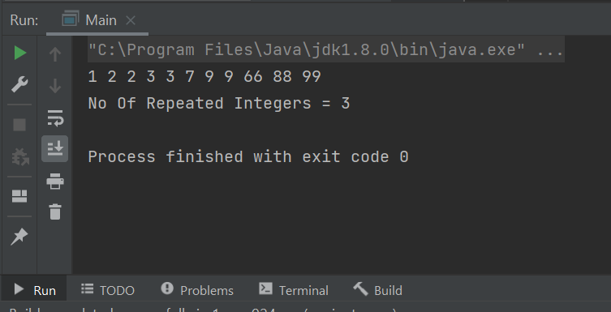

14) public static void main(String[] args) {

int i = 0, j, k;
int[] Dup_Count_arr = {10, 15, 25, 10, 8, 12, 10, 15, 55, 10, 60};

int Size = Dup_Count_arr.length - 1;

while(i < Size)
{
j = i + 1;
while(j < Size)
{
if(Dup_Count_arr[i] == Dup_Count_arr[j]) {
k = j;
while(k < Size) {
Dup_Count_arr[k] = Dup_Count_arr[k + 1];
k++;
}
Size--;
j--;
}
j++;
}
i++;
}
System.out.print("\nThe Final Array after Deleting Duplicates = " );
for(i = 0; i < Size; i++)
{
System.out.format("%d ", Dup_Count_arr[i]);
}
}

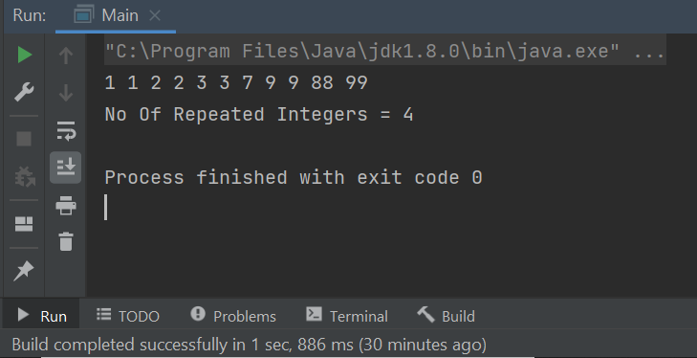

15)public class Main {
public static void main(String[] args) {
int[] arr=new int[]{10,20,30,40,50};
int n= arr.length;
Scanner sc=new Scanner(System.in);
System.out.println("Enter the element and Position to replace");
int Ele=sc.nextInt();
int Pos= sc.nextInt();
for(int i=0;i<n;i++){
if(i+1==Pos){
arr[i]=Ele;
}
}
for (int i = 0; i < n; i++)
System.out.print(arr[i]+" ");
}
}

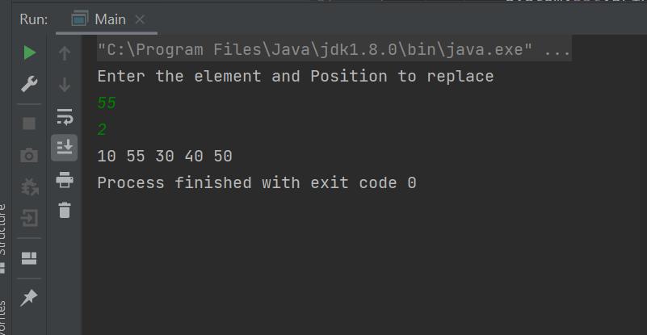

16)
public class Main {
public static void main(String[] args) {
Scanner sc=new Scanner(System.in);
int number, temp, total = 0;
System.out.println("Enter the Number");
int num=sc.nextInt();
number = num;
while (number != 0)
{
temp = number % 10;
total = total + temp*temp*temp;
number /= 10;
}
if(total == num)
System.out.println(num + " is an Armstrong number");
else
System.out.println(num + " is not an Armstrong number");
}
}

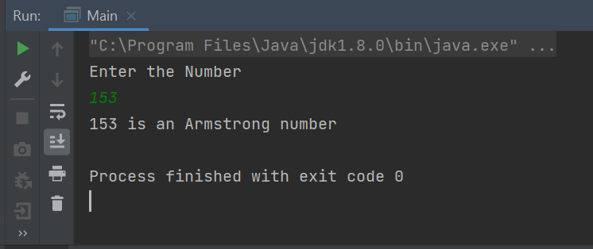

(Done by R.Priyadharshini)

17.In mathematics, a number is called an Automorphic number if the square of the number ends with the same number. Example of Automorphic numbers are:- 5, 6, 25, 76, e.t.c..
Program:
package com.torryharris;
import java.util.Scanner;
public class Main {
public static void main(String[] args) {
Scanner sc = new Scanner(System.in);
System.out.println("Enter a number");
int num= sc.nextInt();
int temp=num;
int square=num*num,c=0;
while(temp>0)
{
c++;
temp=temp/10;
//System.out.println(square);
}
int last=(int)(square%(Math.pow(10,c)));
if (num==last)
System.out.println(num+" is a Automorphic number");
else
System.out.println(num+" is not a Automorphic number");
}
}

Output:
Enter a number
5
5 is a Automorphic number

18.we will develop a Java program for a BMI calculator.
The BMI stands for Body Mass Index. It is a measure of health based on height and weight. It can be calculated by taking the weight in kilograms and dividing it by the square of your height in meters.
Formula for Calculating BMI in Metric Units,
BMI = (Weight in Kg) / (Height in Meters * Height in Meters)
For example,
weight = 75 kg, height = 1.5 m
BMI = 75 / (1.5*1.5) = 33.33
Using the range of BMI, individuals are classified as underweight, normal or overweight. Its value is in a specific range for a healthy individual. The following table shows the main BMI categories,
BMI Range | Category
< 18.5 | Thinness
18.5 – 25 | Normal
25 – 30 | Overweight
> 30 | Obese
BMI calculator finds whether the person is underweight, normal, overweight, or obese. The person who wants to lose their want can use a weight loss calculator which can tell the daily caloric requirements, and many easy tips to lose weight.

Program:
package com.torryharris;
import java.util.Scanner;
public class Main {
public static void main(String[] args) {
Scanner sc =new Scanner(System.in);
System.out.println("Enter your weight in kg");
double weight_kg = sc.nextDouble();
System.out.println("Enter your height in kg");
double height_m = sc.nextDouble();
double BMI= (weight_kg/(height_m*height_m));
if (BMI<18.5)
{
System.out.println("Under weight");
}
else if (BMI<25)
{
System.out.println("Normal");
}
else if (BMI<30)
{
System.out.println("Overwight");
}
else
{
System.out.println("obese");
}
}
}
output:
Enter your weight in kg
55
Enter your height in kg
1.5
Normal
19.Perfect number:- A number whose factors sum except itself, is equal to the same number is called a perfect number.
Program:
package com.torryharris;
import java.util.Scanner;
public class Main {
public static void main(String[] args) {
Scanner sc =new Scanner(System.in);
System.out.print("Enter the number:");
int n=sc.nextInt();
int sum=0;
for (int i=1;i<=(n/2);i++)
{
if(n%i==0)
{
sum= sum+i;
System.out.println(sum);
}
}
if (sum== n)
{
System.out.println(n+" is a perfect number");
}
else
{
System.out.println(n+" is not a perfect number");
}
}
}

Output:
Enter the number:496
1
3
7
15
31
62
124
248
496
496 is a perfect number

20.Write a Java program to find the second largest number in Java.
Program:
package com.torryharris;
public class Main {
public static void main(String[] args) {
int[] arr ={70,100,150,99,50,98};
for (int i=0;i<arr.length;i++)
{
for (int j=i+1;j<arr.length;j++){
if (arr[i] < arr[j]){
int temp = arr[i];
arr[i] = arr[j];
arr[j]=temp;
}
}
}
System.out.println((arr[1])+" is the second largest number.");
}
}
Output:
100 is the second largest number.
